Raymond Shiner

Databases - Lab 4 Submission

**DATABASES - LAB 4**

1.

select order_num, firstname, lastname, orderdate

from ORDERS join CUSTOMERS

on ORDERS.Customer_num = CUSTOMERS.Customer_num

where shipdate is null

order by orderdate asc

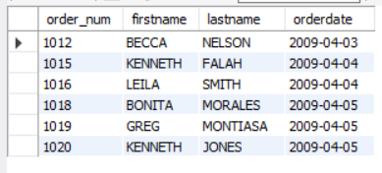

2.

select ORDERS.customer_num, firstname, lastname, ORDERS.order_num

from CUSTOMERS JOIN ORDERS JOIN ORDERITEMS JOIN BOOKS

on ORDERS.Customer_num = CUSTOMERS.Customer_num

AND ORDERS.Order_num = ORDERITEMS.Order_num

AND ORDERITEMS.ISBN = BOOKS.ISBN

where state = 'FL'

and category = 'COMPUTER'

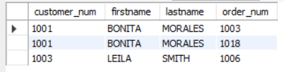

3.

select distinct BOOKS.Title

from CUSTOMERS JOIN ORDERS JOIN ORDERITEMS JOIN BOOKS

on ORDERS.Customer_num = CUSTOMERS.Customer_num

AND ORDERS.Order_num = ORDERITEMS.Order_num

AND ORDERITEMS.ISBN = BOOKS.ISBN

where firstname = 'JAKE'

and lastname = 'LUCAS'

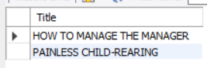

4.

select title, orderdate, (PaidEach - Cost) as profit

from CUSTOMERS JOIN ORDERS JOIN ORDERITEMS JOIN BOOKS

on ORDERS.Customer_num = CUSTOMERS.Customer_num

AND ORDERS.Order_num = ORDERITEMS.Order_num

AND ORDERITEMS.ISBN = BOOKS.ISBN

where firstname = 'JAKE'

and lastname = 'LUCAS'

order by orderdate asc, profit desc



5.

select BOOKS.ISBN, title

from BOOKS NATURAL JOIN BOOKAUTHOR NATURAL JOIN AUTHOR

where Lname = 'ADAMS'



6.

select Fname, Lname, title

from CUSTOMERS

NATURAL JOIN ORDERS

NATURAL JOIN ORDERITEMS

NATURAL JOIN BOOKS

NATURAL JOIN BOOKAUTHOR

NATURAL JOIN AUTHOR

where firstname = 'BECCA'

and lastname = 'NELSON'

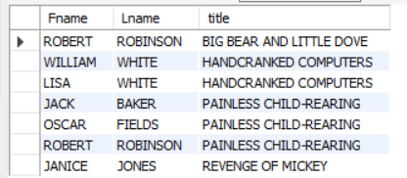

7.

select title, ORDERS.order_num, state

from CUSTOMERS NATURAL JOIN ORDERS NATURAL JOIN ORDERITEMS RIGHT JOIN BOOKS

ON ORDERITEMS.ISBN = BOOKS.ISBN

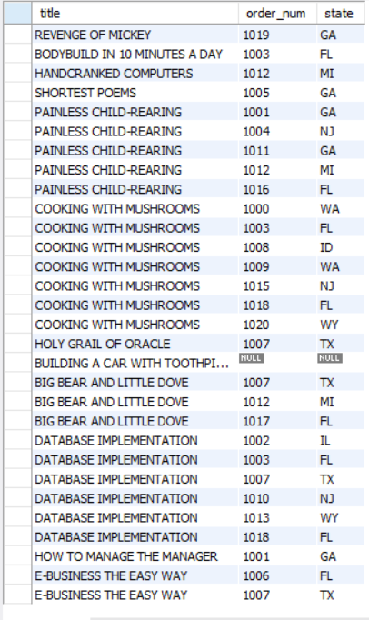

8.

select COUNT(*)

from BOOKS

where retail > 30

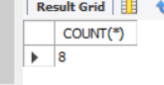

9.

select max(PubDate)

from BOOKS

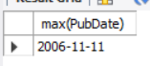

10.

select SUM((Retail - cost) * quantity)

from BOOKS NATURAL JOIN ORDERITEMS NATURAL JOIN ORDERS

where CUSTOMER_NUM = 1017

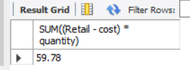

11.

select MIN(retail)

from BOOKS

where category = 'CHILDREN'

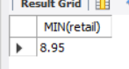

12.

select customer_num, COUNT(*)

from ORDERS NATURAL JOIN CUSTOMERS

where order_NUM is not null

group by CUSTOMERS.Customer_num

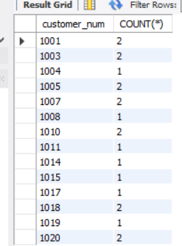

13.

select name, category, AVG(retail)

from BOOKS NATURAL JOIN PUBLISHER

group by category, name

having avg(retail) > 50

order by name

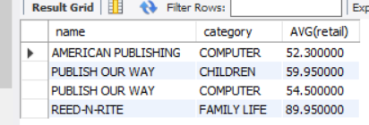

14.

select firstname, lastname, order_num, sum(retail * quantity) as total

from CUSTOMERS NATURAL JOIN

ORDERS NATURAL JOIN

ORDERITEMS NATURAL JOIN BOOKS

where state = 'FL' or state = 'GA'

group by order_num

having sum(retail * quantity) > 80

ORDER BY sum(retail * quantity)

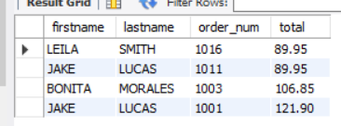

15.

select max(retail)

from BOOKS NATURAL JOIN BOOKAUTHOR NATURAL JOIN AUTHOR

where fname = 'LISA' and lname = 'WHITE'

